Photoshop
Double Exposure
Please leave this packet behind for the next class.
It is also located on my Weebly. Cariwerz.weebly.com

Below are the steps to guide you through the Double Exposure Photoshop Project.

Starting your canvas

1. Open Photoshop by seraching for Adobe Photoshop in the start window.

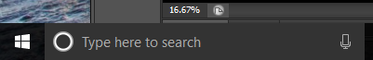

2. Starting a canvas in photoshop
Click File > Click New
Make it match the photo below. Title it your name, Period, and Double Exposure
(you can’t use / in your titles when saving it so I use a period to write your class, example 1.3)
The resolution should be like to following:
Internet Resolution 72
Printer Paper Resolution 150
Poster Resolution 300
The higher you make the resolution the bigger the file is (make it render and save slower).

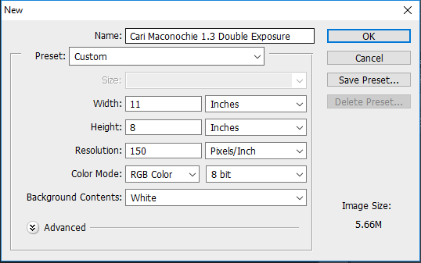
Change the measurement to Inches

3. Import your portrait photo
I shrink my Google drive screen so I can see Photoshop and my Google drive at the same time.
Step 1. Download your image from Google drive
Or save the image onto the desktop from the internet
Or copy the image “control C”

Step 2: drop the image onto the canvas
Or paste the copied image “Control v”

4. Resize the image to fit how you like it.
Use the arrow tool to move things.
If you do not want it to skew or warp your image, hold shift while you are resizing from the corner.
Once it is the correct size click enter to apply the transformation.
If you want to transform it again click “control T” for transform.

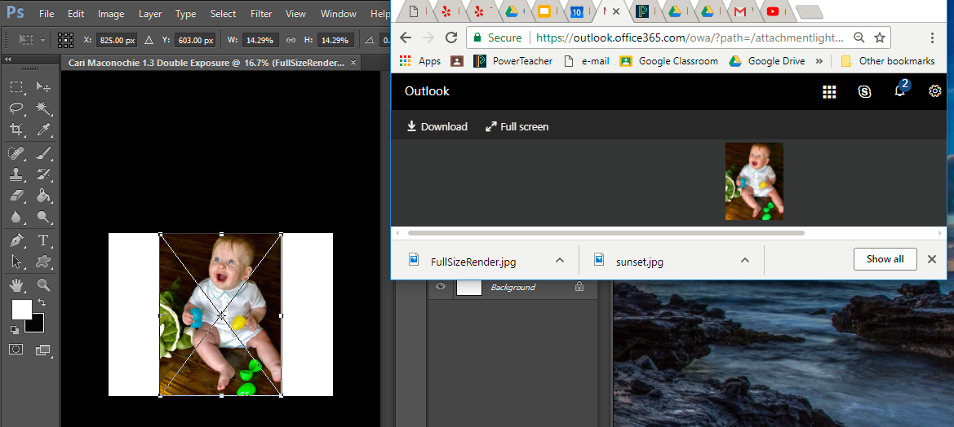

Editing the image

5. You must Rasterize the image so you can edit it in photoshop.
Make sure the correct layer is selected.
Click Layer > Rasterize > Smart Object
The little square in the preview window will disappear.
Before rasterized 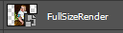
After rasterized 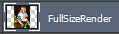

6. Make a copy of the original photo.
Click on the layer with your photo on it. (See the green arrow) Drag it down to the paper icon to create a duplicate.
Change the title to “Original” by double clicking on it.
The reason we do this is so you can refer back to it if needed. You can click the eyeball to hide it from the canvas.
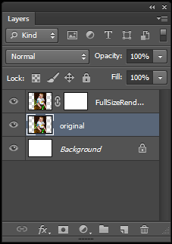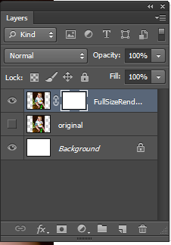

using the Mask Layer

7. adding a Mask layer
You never want to permanently delete the background. You can NEVER get it back.
Instead it’s professional to mask it away.
It works best if your photo has a solid contrasting background.
Zoom in so you can see it really well.
(See the green arrow) Click Add Mask Layer
This allows you to ghost erase. This means you will paint with invisible ink to hide unwanted areas. The benefit of using invisible ink instead of an eraser tool is you can go backwards and add the image back at any time.
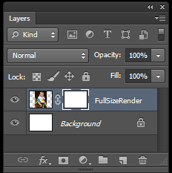

Brush tool

8. Change the paint brush setting
You want to select the mask layer by clicking on the white paper beside your photo.
Then you use the paint brush tool to hide or reveal the image.
Set the paintbrush style and size first. I usually start with a medium size like 30 then go up or down as needed. I use the hard edge unless you want a hazy faded outline then use the blurry style.

9. Masking out the background on the layer mask.
Black ink is the invisible ink hiding areas
White ink brings back the image.
You must be on the mask layer for it to work.
If you are on the mask layer you will see brackets around the white box.
Now you are ready to paint the background with black ink to hide it.

Using the selection tool

10. hiding areas using the layer mask
Use the paint brush tool
Paint with black paint to hide areas
Paint with white paint to reveal the areas back to the way they were before.
*Make sure the original photo is hidden by clicking the eye icon or you will not see
your edits. See step 6
To change the colors to black and white see the image below.
This arrow icon will switch the colors

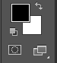
This is your background color
This is your foreground color

Selecting areas

11. using the magic wand or using the quick selection tool
Magic Wand Tool selects all like colors. You have to hold shift to select multiple things at once.
Quick Selection Tool you click and drag along the background and it selects like colors as you drag the tool over an area. Your selection is affected by the size of your brush.

Editing your selection

12. Quick mask mode (see phtos on the next page)
Click on the quick mask mode icon to edit a selection. (See the green arrow)
The part of the photo that is NOT selected will turn red.
The part of the photo that is in color is the selected area.
Use the black paint brush to add red paint. This is area that is not selected. Black paint = not selected
Use the white paint brush to erase red paint. This is the area that is selected. White paint = selected
To deselect after you finish click Control D.

In this photo you can see the leg and head are not selected. This is photo shows what the quick mask
looks like. Here the background is selected.
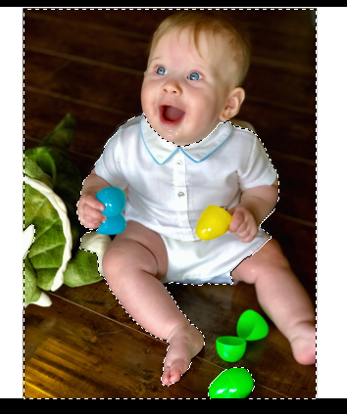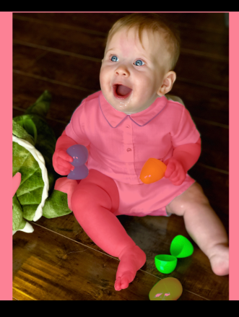

I edited the selection so all of Logan is red If you click the quick mask mode button
So I can hide the background (the selected area). again you will see what your edited selection
I did this by painting Logan with black paint and looks like.
Painting the background with white paint.
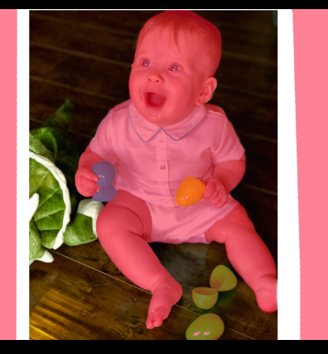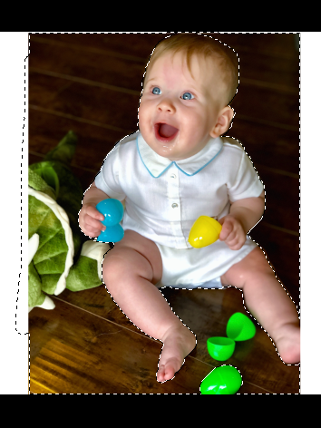

Here is the final picture with the background hidden.
Click on the mask layer. Then paint the selection using black “invisible” ink. The mask layer is the only place you can get the invisible ink to work to hide areas. You paint with white to bring the photo back. The click control D to deselect.
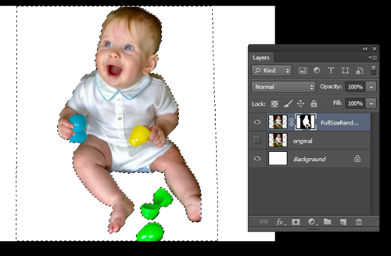
You can see the mask layer is selected because it has brackets around it.

adding a background photo.

13. Now you must add a photo to represent your poem or quote.

You may do this any way you would like.

remember to be different.

do the unexpected.
Create a new layer by clicking the piece of paper. You can drag that layer you just created and rearrange it in any order in the layers menu.

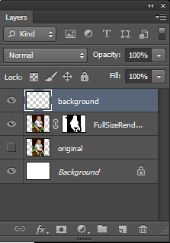
New layer. Click it to add a layer.
Drag a layer to it to copy that layer.

Drag and drop a new photo onto the background.
You can play with the Image > Adjustments options to adjust the photo.
Or you can play with Filters to add special effects.
Experiment with different photos. You can also Click Control T and change the size or location.
You can also flip it backwards. Use the arrow tool to move the photo around.

You can see the background is under the layer with the photo of Logan.

You can click the eye icon on the layers menu to hide that layer and try a new one.

Option 2 is better, but still doesn’t fit the photo of Logan very well. I will keep trying different options.

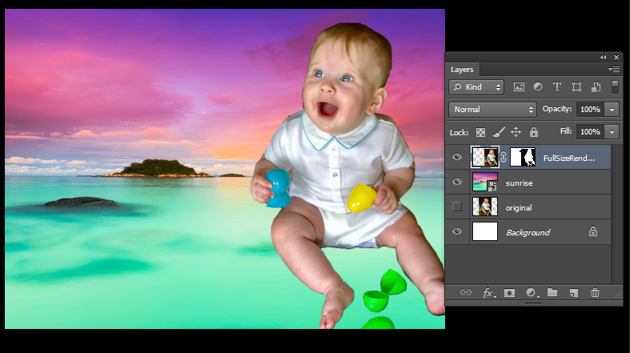

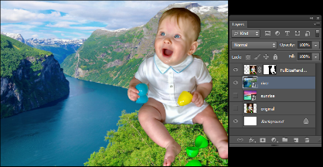

Saving

Save it as a photoshop document so you can continue to edit it.

Click File> Save As> Photoshop (*.PSD:*.PDD)
Check off the following boxes:
Layers
ICC Profile
Use Lower Case extension
Title it as your name period and double exposure project
Place it in your folder on your desktop.
Then, save it to your Google Drive Art folder
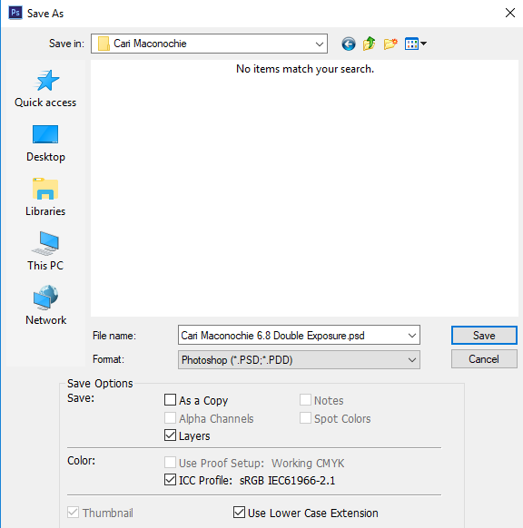

_{Sign out!}
Click on the person icon and sign out
_{then shut down}

place the computer in the numbered cart

