Photoshop Cartoon look
Double Exposure Project
Please leave this packet behind for the next class.
It is also located on my Weebly. Cariwerz.weebly.com

Below are the steps to guide you through the how to make your picture look like a stylized cartoon.

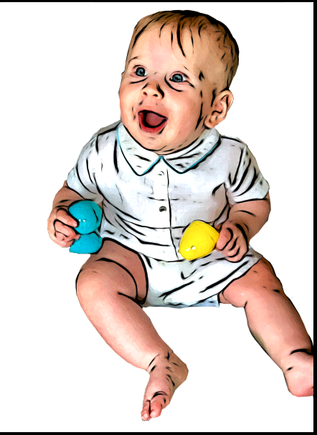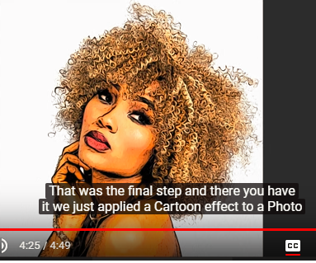

Layers

1. Make a copy of your portrait
After you mask the background out, make a copy of your picture. To do this click on the layer you want to copy and hold the click button while you drag it down to the paper icon.

If you just click the paper icon it creates a blank layer.
Title the new layer Copy

2. Select the picture in the copy layer so you can add filters to it.

3. Select Filter > Filter Gallery > Open ARtistic File
I encourage you to experiment with other filters as well.

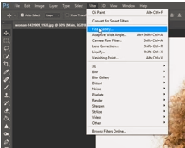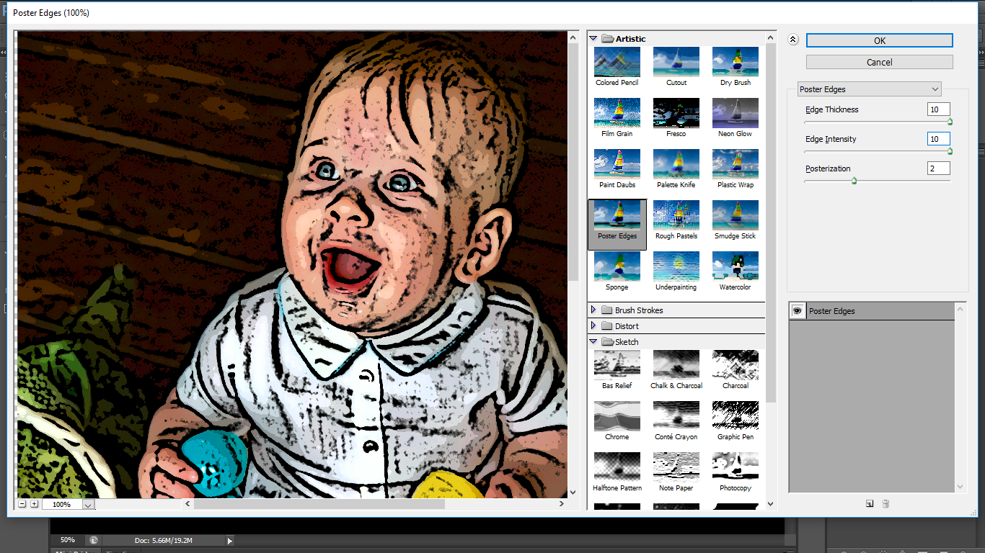
Open the artistic folder

=for the
After you click on a filter you can change the settings.
A suggested setting for Poster Edges looks like the following:
Edge Thickness 10,
Edge Intensity 10,
Posterization 2.
You can of course change it to fit your needs.

4. Threshold
Set the Threshold to 49 by going to Image > Adjustments > Threshold
This will make him black and white.
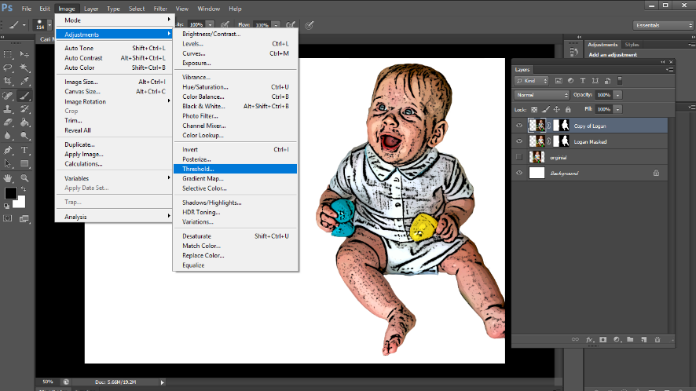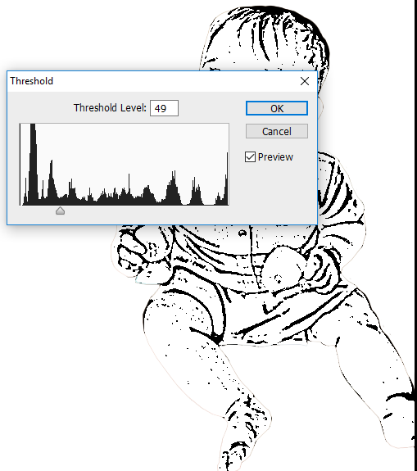

5. Oil Paint filter
This sofens the poster edge filter. It is Optional to add this filter
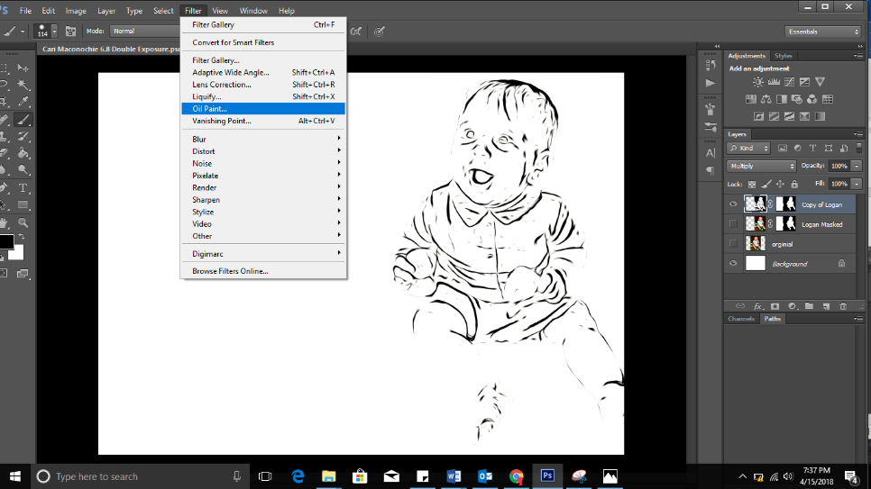

Bringing color back

6. Multiply
Filtered portrait is selected
Colored portrait is below
Click here to change normal to multiply

7. Adjust the saturation, color, levels, or any other setting to fit your desired look.

