Alebrije Spirit Animals
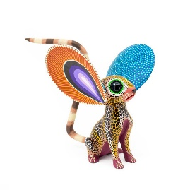Spanish History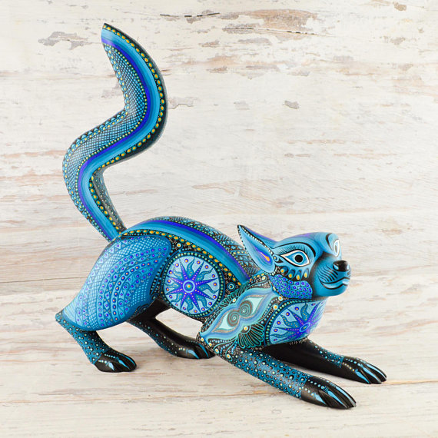
The Alebrijes are imaginary creatures that have elements from different animals such as dragon bodies, bat wings, wolf teeth and dog eyes. Colorfully painted, they were originally made with papier mache but nowadays they are also wood carved.
The Alebrije was created by Pedro Linares Lopez in the 1930’s. The story says that while Pedro was very ill he had a feverish dream where he saw mythical creatures and heard them say the name alebrije. After that Pedro began to represent the strange creatures in papier mache.
Pedro Linares' work sold locally for many years counting customers like Diego Rivera and Frida Kahlo until a documentary film made by Judith Bronowski in 1975 gave him international fame. In 1990 he received the National Prize for Popular Arts and Traditions. Linares passed away in 1992.
Math Congruent Triangles
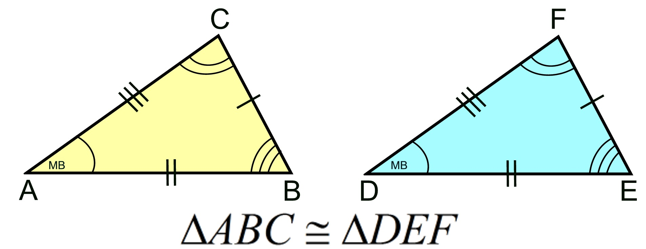
Art Illustrator
This was the students first time using Illustrator. Illustrator is a vector based program that is widely used to create logos, posters, brochures, cartoon characters, and other fine arts. Students traced their spirit animals from the Spanish Alebrije tradition by using triangles. Students had to prove that 10 of their triangles were examples of congruent triangles which they learned about in Math class.
Can the QR Code below to see more possibilities Adobe Illustrator has to offer.

