1 Point Perspective Table in a Room

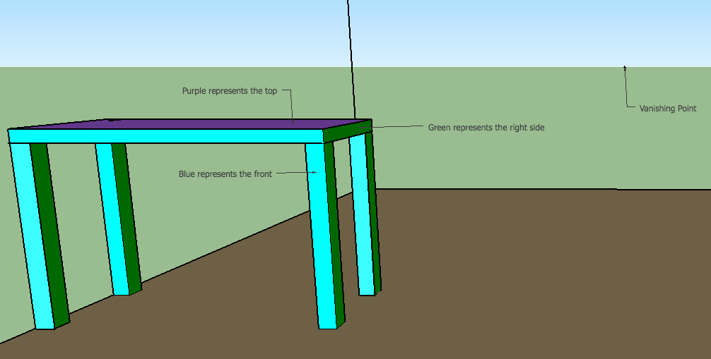

Draw your room in 1 point perspective
Make sure each corner lines up with the vanishing point.

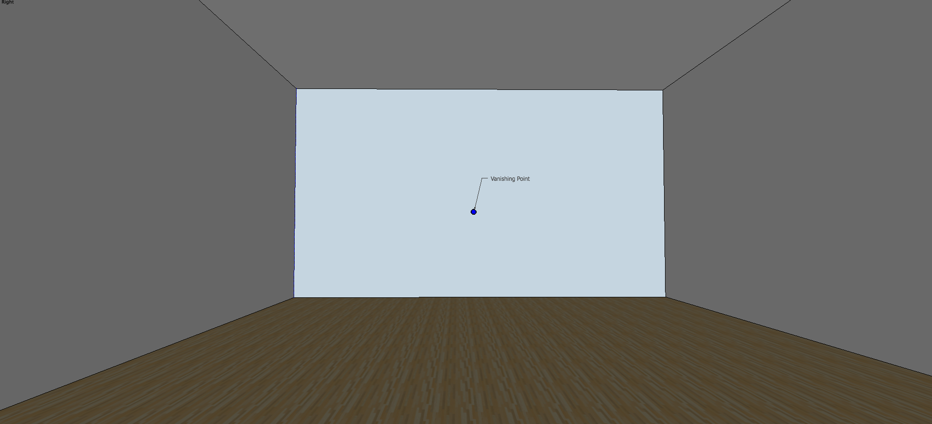

- Draw a rectangle or square (light blue) line up the edges with the side of the paper.

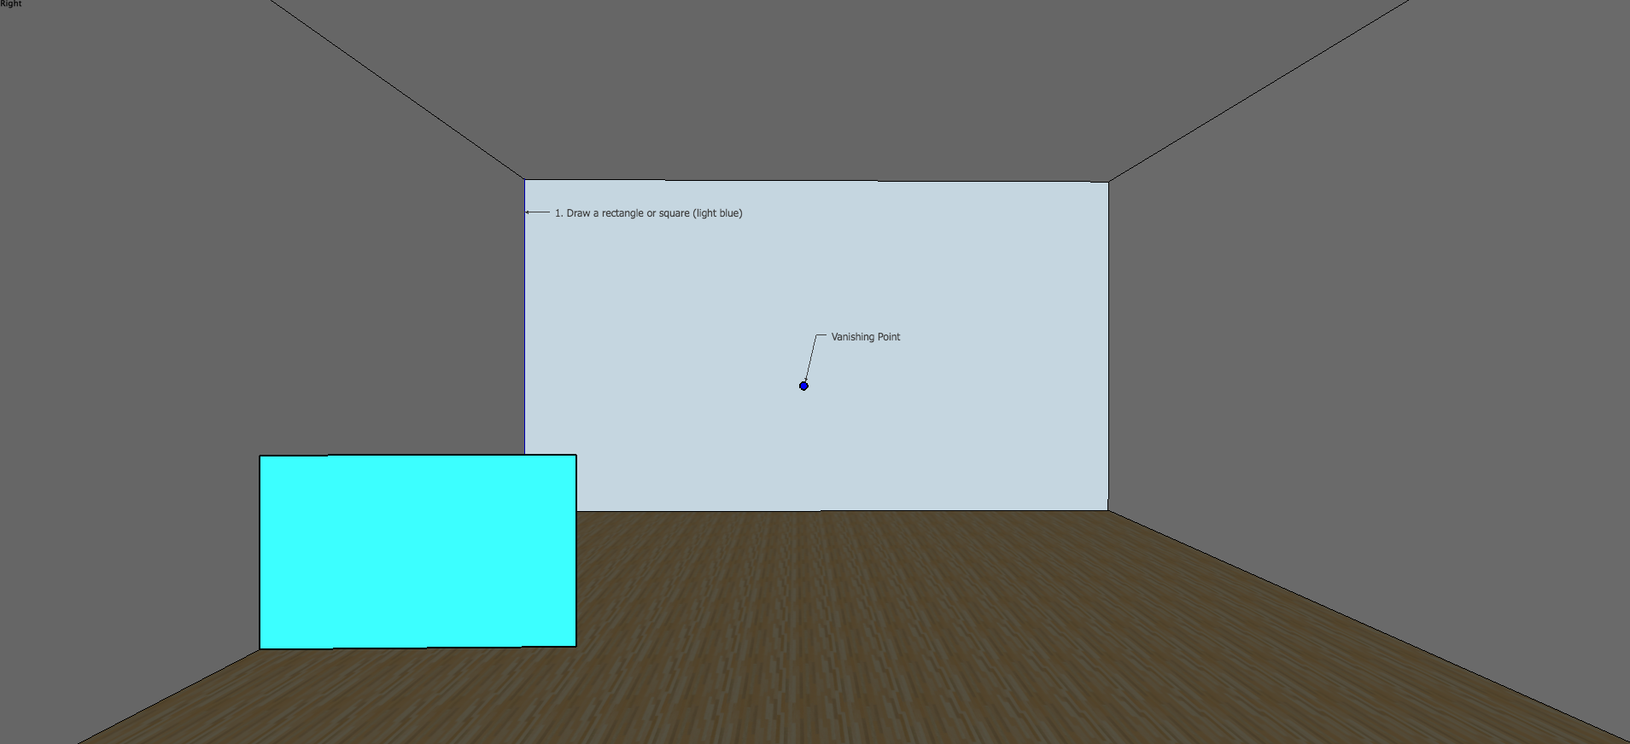

2. Draw vanishing lines to the vanishing point from each corner of the blue square.

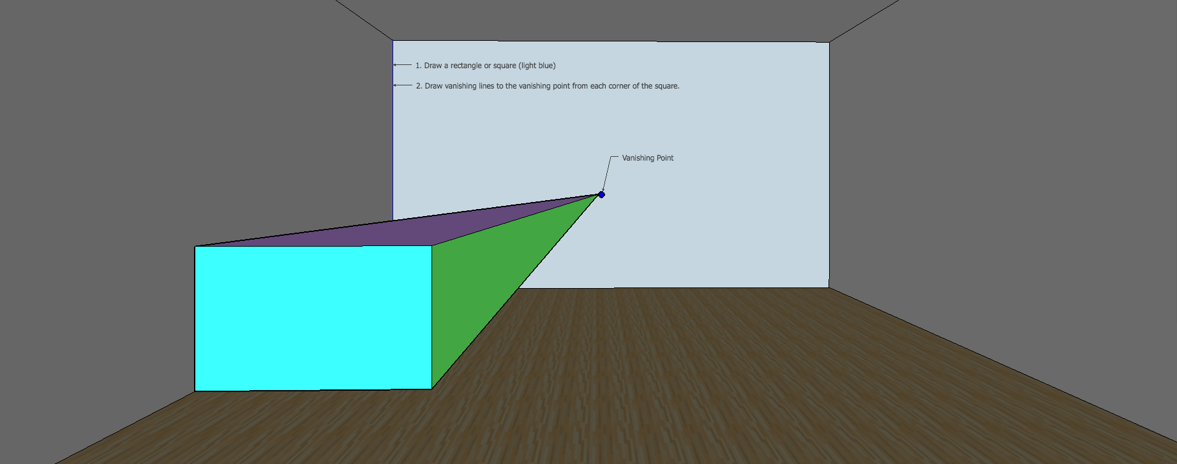

3. Draw a cut off line at 90* and 180* to determine the length of the table. It has to be inside the floor space.
4. Draw the shape of the table in the front (Blue side) This looks like a smaller rectangle.

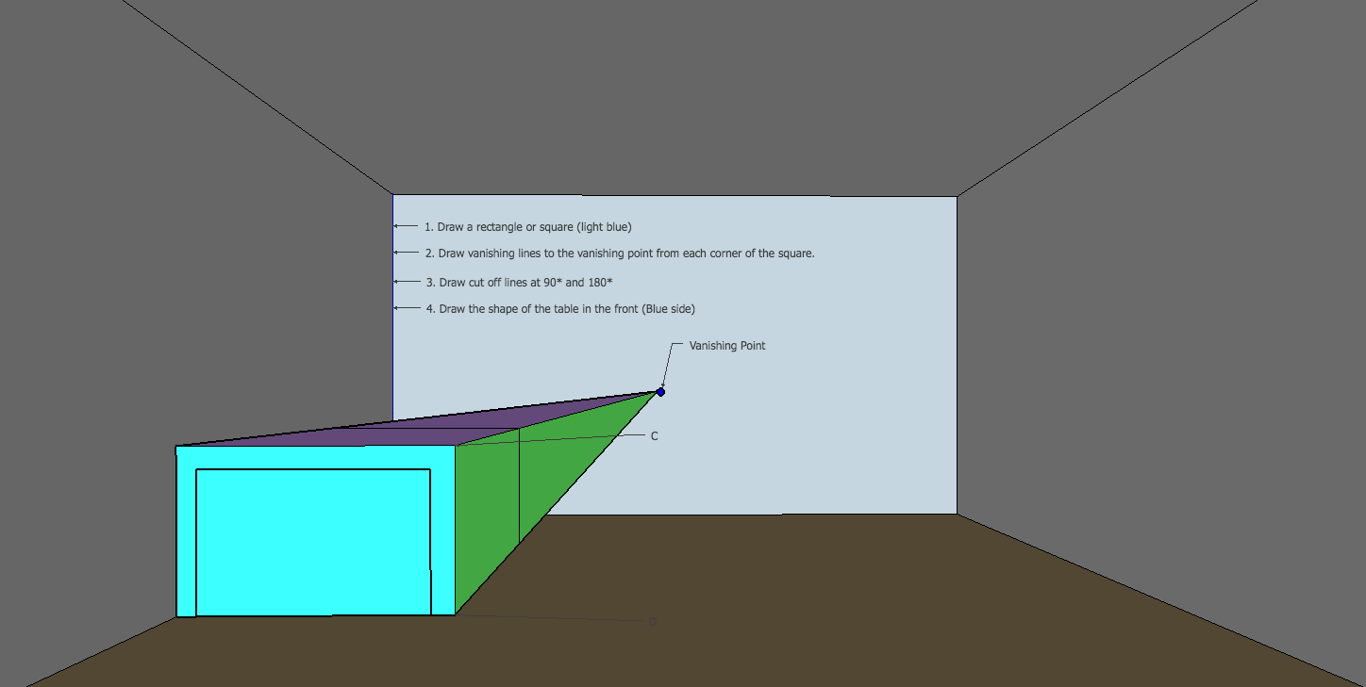

5. Draw vanishing lines from the corner of both legs.

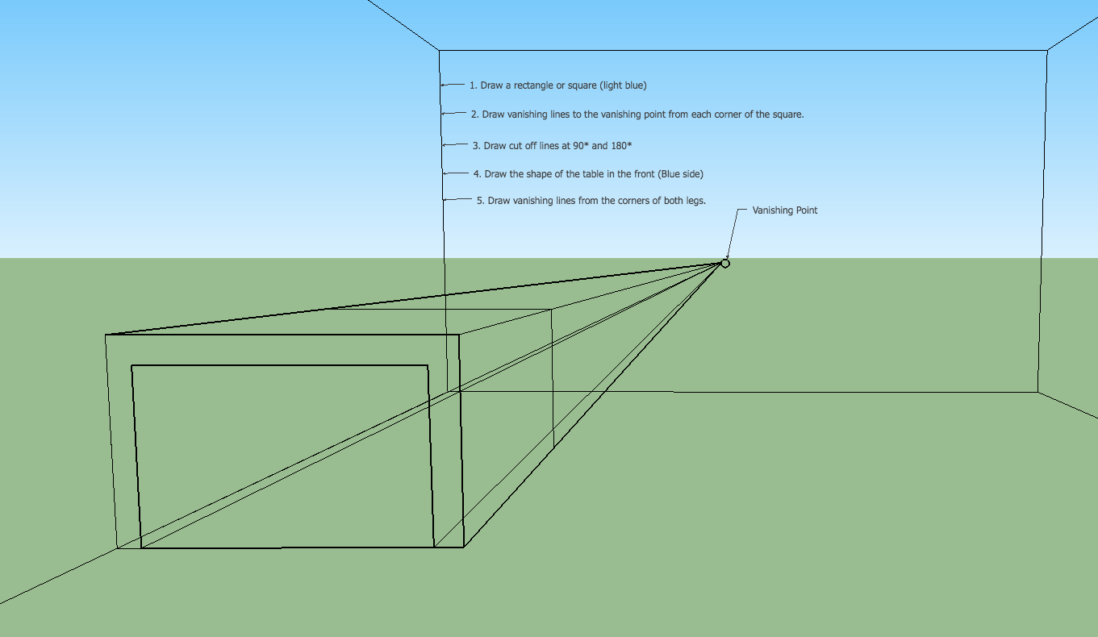

6. Draw the top of the table so it looks like a glass cube. To do this your draw a vanishing line from every corner, then add a cut off line in the back left corner.

7. Draw the cut off lines for the front legs.

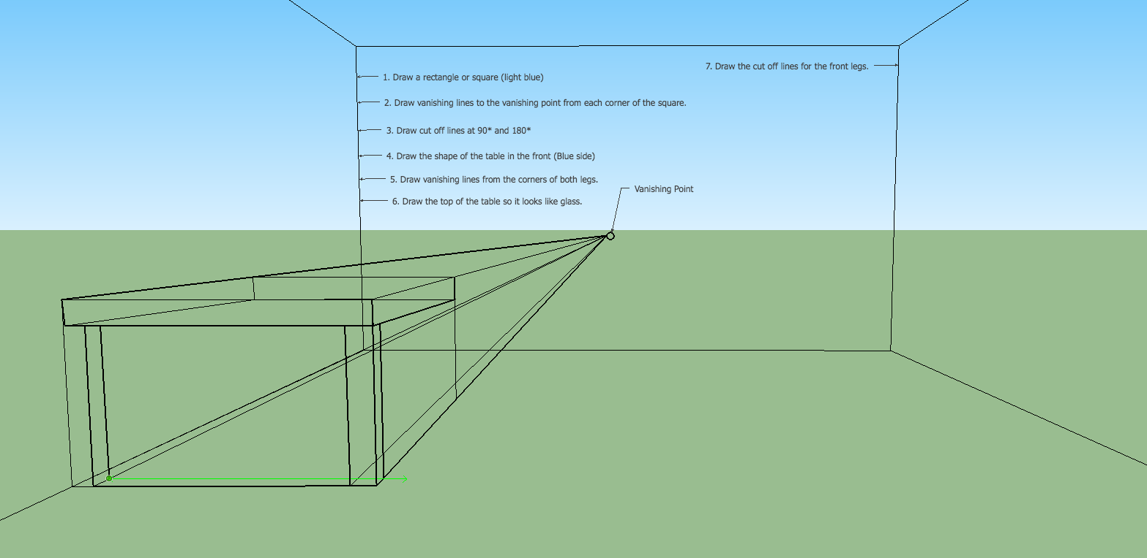

Notice the front table leg cut off lines line up equal along a horizontal line.

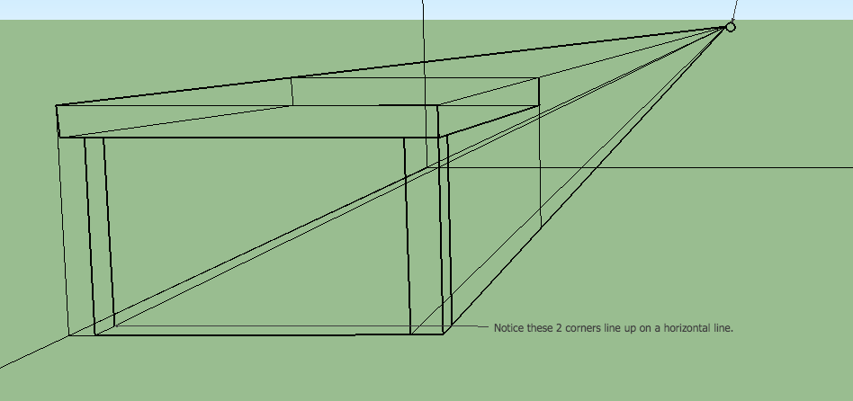

8. Draw the back legs, they fit in the same vanishing line path created from the front legs.

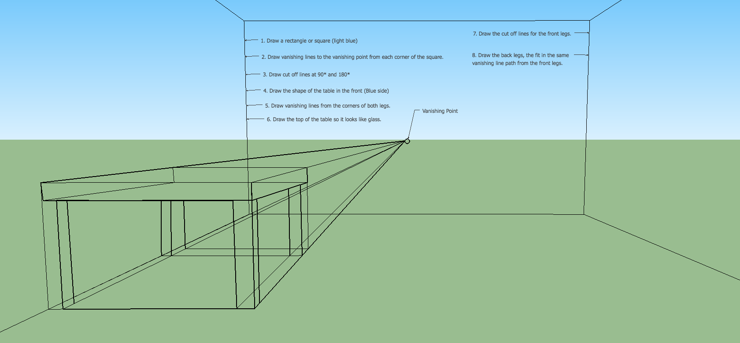

Notice the horizontal lines below.
They show you that both legs in the back are the same height and width.

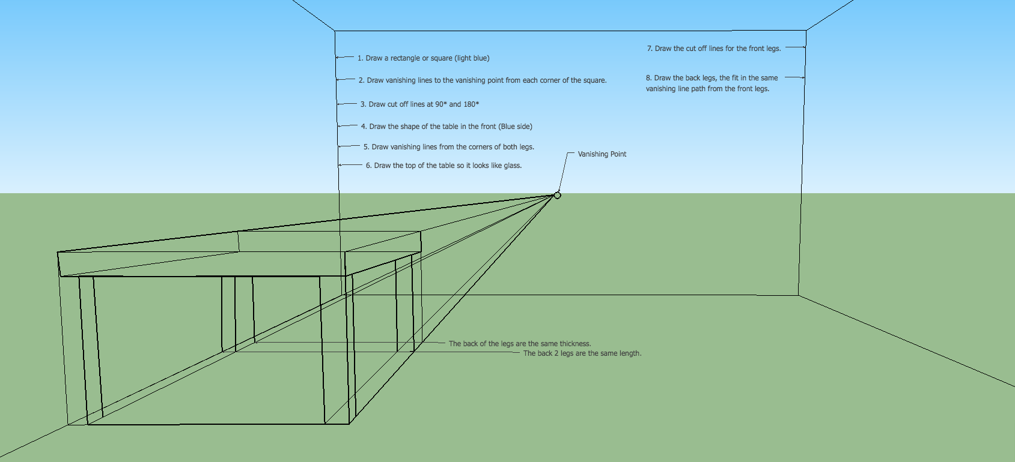

Here is another point of view with the legs shown as transparent.

